Sport City
By Meraki
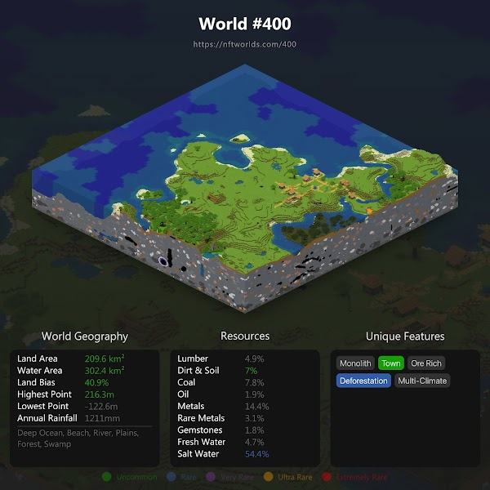
General plan size
400 x 400

Ideas
Create a city with a stadium in the centre, surrounded by a beach where you can find lots of sporting activities.
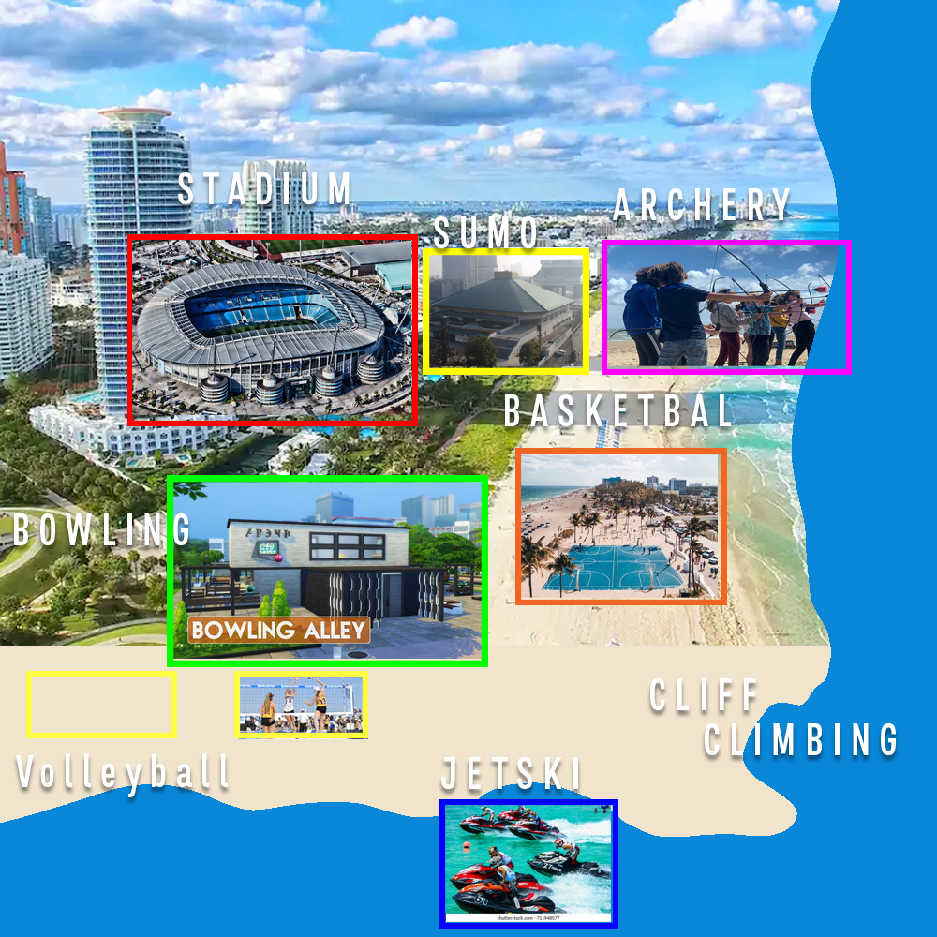

Towards the coast
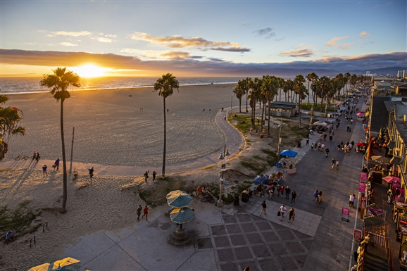

Jetski Race
A jetski race on the water, by the beach. This would be a racing game where you would need to go through hoops which could potentially give you power ups or speed boosts.
Reference: https://youtu.be/CE5irfVMJk0?t=6
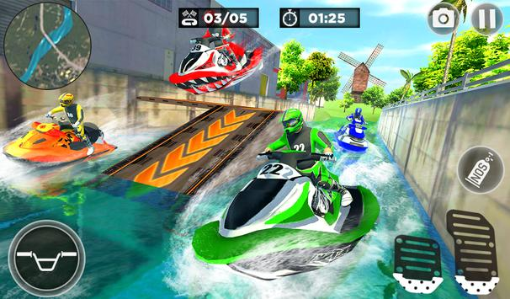

Football throwing
A football throwing competition where you’d need to throw a football with at a specific timing and specific power for it to hit the target.
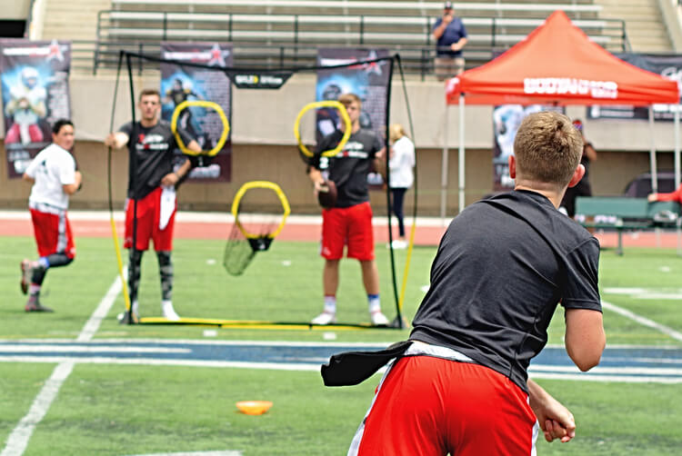

Basketball 3 Pointer
This would be a basketball court right outside the beach, just like you have at bigger beaches towards the coast. We could have a 1v1 and 3v3 gamemode.

Volleyball
A volleyball court by the beach, where you can 1v1 other players.

In the city

Bowling Alley
A volleyball court by the beach, where you can try to score the highest scores.
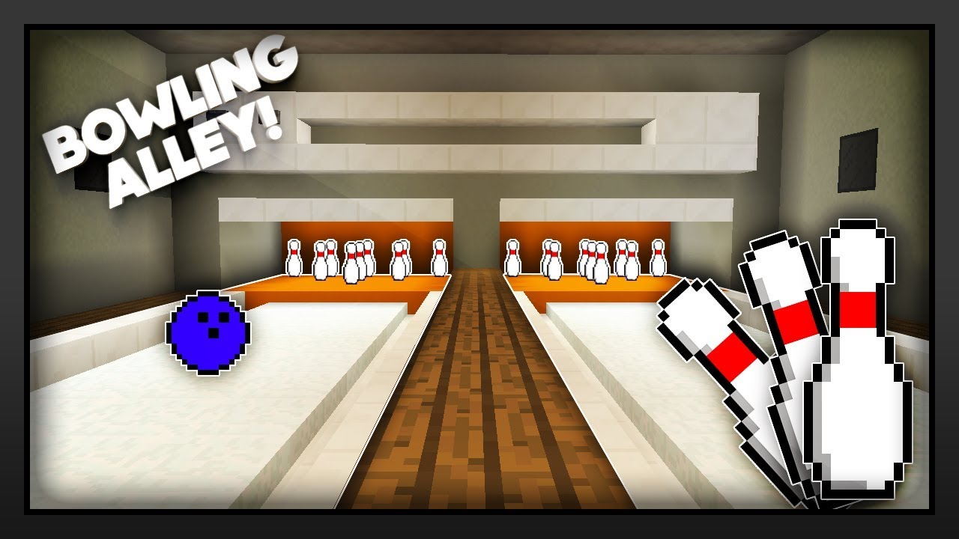

Sumo Wrestling
Sumo wrestling would be done in the city, it’ll be like Mincraft PvP, where you would need to punch/push your opponent off the circle
an arena in the center of a building, people will mostly likely be able to join through a command
Minecraft: SUMO WRESTLING (KNOCK THE OTHER TEAM OFF AND KILL THEM!) Mini-Game
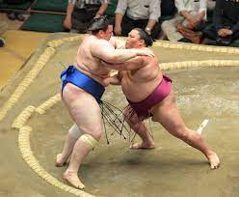

Soccer
Soccer would be the “main” game of all. In the huge stadium in the middle of the city soccer will be played.
Reference : https://www.youtube.com/watch?v=vvcOvdYj614&t=123s
Sizes: 50 x 100

